# **Department of Computer Science and Engineering Islamic University of Technology (IUT)** A subsidiary organ of OIC

# **Lab Report 01**

# CSE 4412: Data Communication and Networking Lab

## 

## **Name: Adid-Al-Mahamud Shazid Student ID: 210042172 Section: SWE (B) Semester: Winter Academic Year: 2023-24**

**Date of Submission: 28 January, 2024**

### **Title:** Configure router using static routing to connect multiple networks in Cisco Packet Tracer.

### **Objectives**:

1. Understand how to operate Cisco Packet Tracer
2. Learn to create and connect multiple networks using static routing
3. Understand wiring of different network components like router, switch, PC etc.
4. Configure router and switch interfaces
5. Verify connectivity of the network
6. Understand the basics of IP Subnetting
7. Learn to subnet a network following given specifications

### **Diagram of the experiment:**

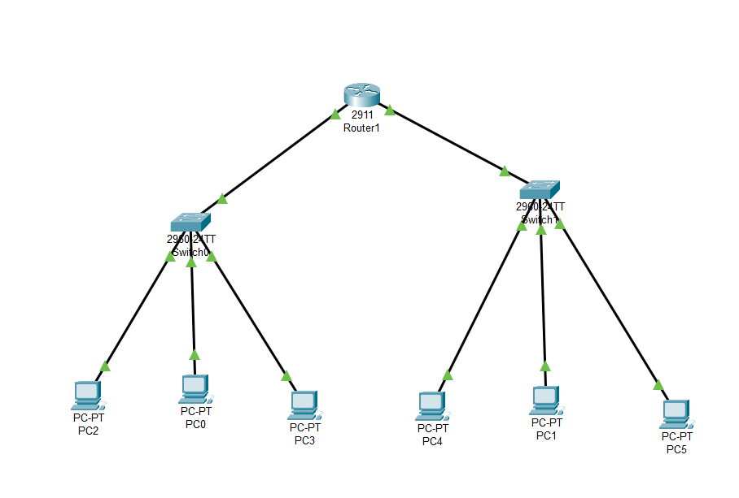

### **Working Procedure:**

* First, I created the mentioned topology by connecting a Router with switches and various devices using Ethernet cables.
* Then I changed the hostname of the Router to ‘172’

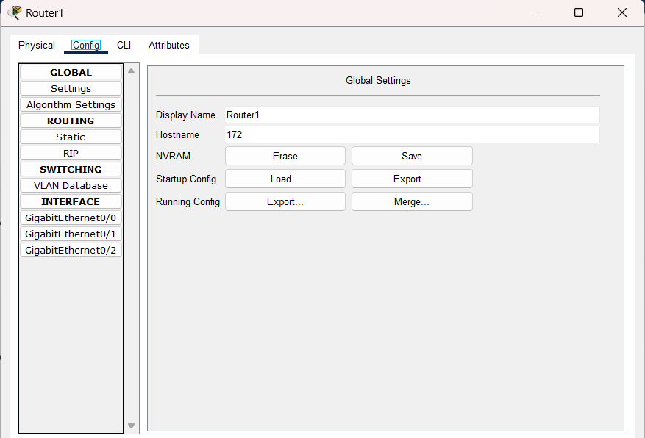

* Then I configured router interfaces gigabitEthernet 0/0 with ip address 192.168.72.1 and router interfaces gigabitEthernet 0/1 with ip address 192.168.82.1

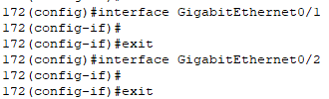

* Then I configured IP of each PC as instructed in the task.

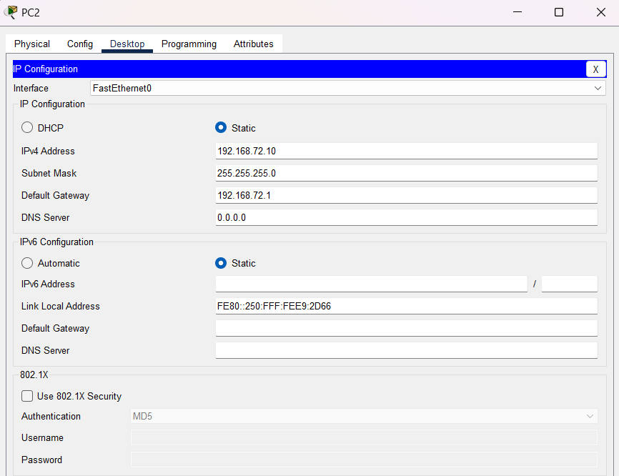

* Then I checked status of each of the interfaces and found all are linked up.

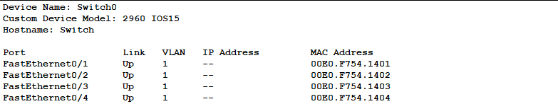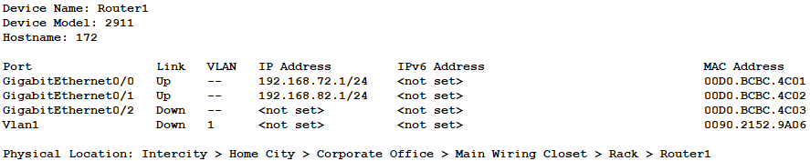

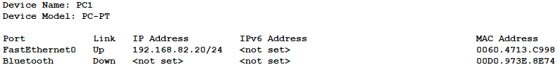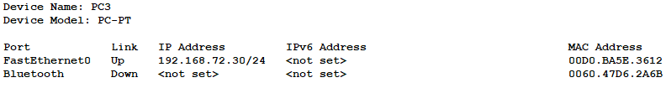

* 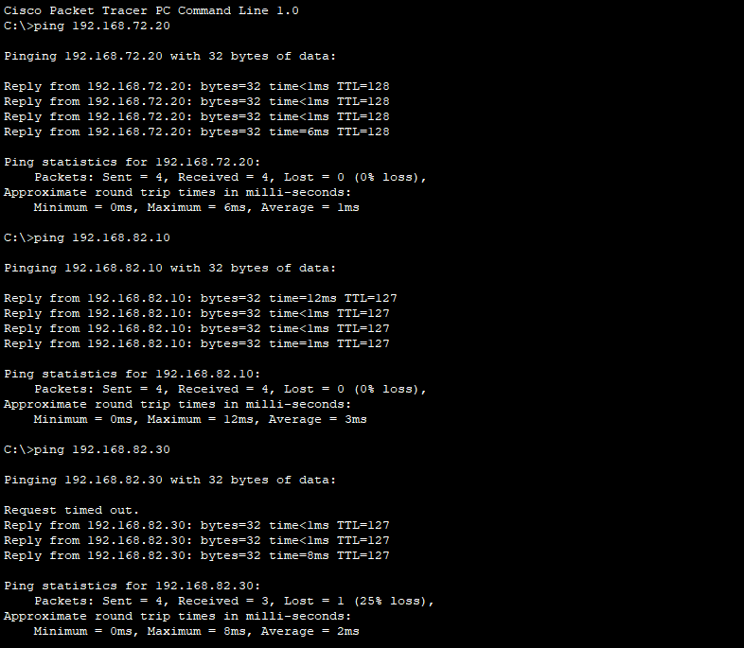Finally, I verified if I can send data through the devices or not. And using ping, I was be able to send data from a device connecting to the left switch to devices connecting to both left and right switch.

### **Questions (Answer to the point)**:

**Q1.** Write the command to check the status of all interfaces in a router.

**Ans:** show interface status

**Q2.** Why do we use switches and not hubs?

**Ans:** Switches are preferred over hubs due to their operation at the data link layer, enabling efficient data transmission by directing information only to the intended devices and avoiding unnecessary broadcast. Switches create separate collision domains for each port, reducing collisions and enhancing network performance. With dedicated bandwidth for each port, switches manage bandwidth more effectively than hubs, allowing concurrent communication without degradation. Additionally, switches provide security by isolating traffic between ports, and despite a potentially higher initial cost, they are considered more cost-effective in the long run due to their improved performance and efficiency. That’s why in most cases we use switches instead of hubs.

**Q3.** How do you make all the configuration changes in a cisco device persistent? What would happen if you don’t do this?

**Ans:** To make configuration changes persistent on a Cisco device, we need to save the running configuration to the startup configuration. We may use the ‘copy running-config startup-config’ command to save the running configuration to startup configuration.

If we don't do this, changes will be lost after a reboot, potentially causing network disruption and misconfigurations. Also, there is chances in loss of data.

**Q4.** What are the interfaces of the router? Why are they necessary?

**Ans:** Router interfaces, such as Ethernet enable connectivity to networks, facilitate routing, and

allow for WAN connections. They play a crucial role in configuring, segmenting, and managing

network traffic.

**Q5.** Why is default gateway necessary?

**Ans:** A default gateway is crucial for devices in a network to communicate with other networks. Serving as the exit point, it facilitates efficient data routing between networks through gateways or routers, ensuring optimal paths for communication.

### **Challenges:**

* I faced challenges working with the commands as those was completely new to me.
* Also, I faced some issues sending message properly at first, but later it was okay.